Automation script to set the size of browser window

Step-1 here go to file select NEW>MAVEN PROJECT

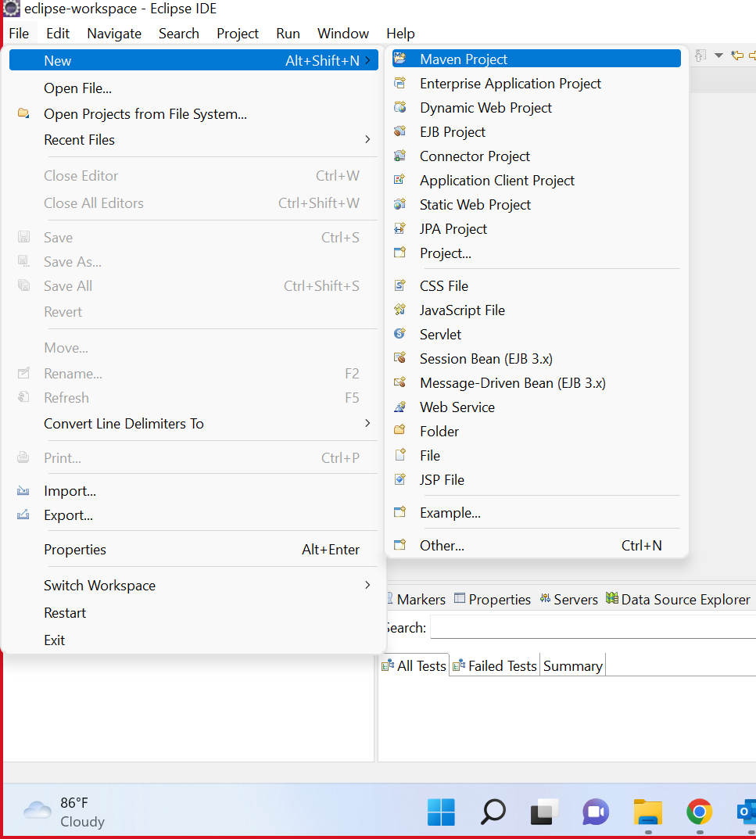

Step-2 check the create the sample project

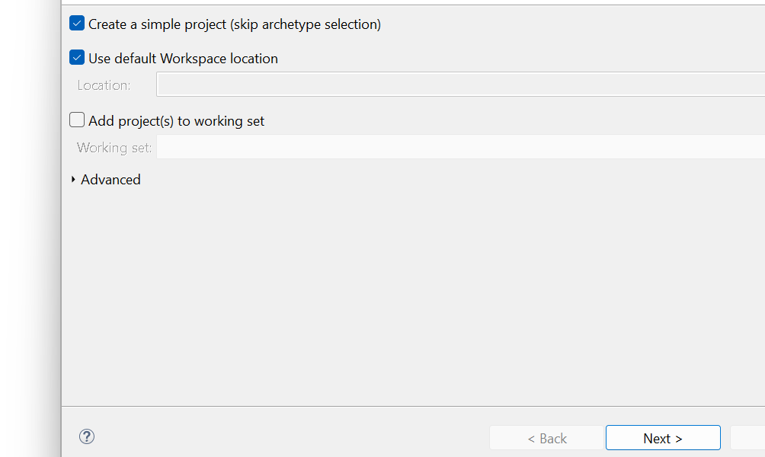

Step-3 select the com.tester>new>class

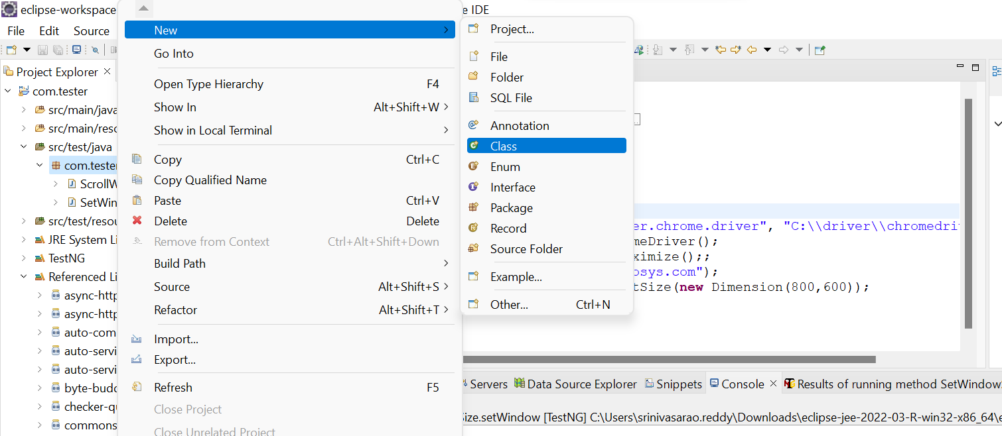

Step-4 after the step-3 it will ask the group id and artifact id

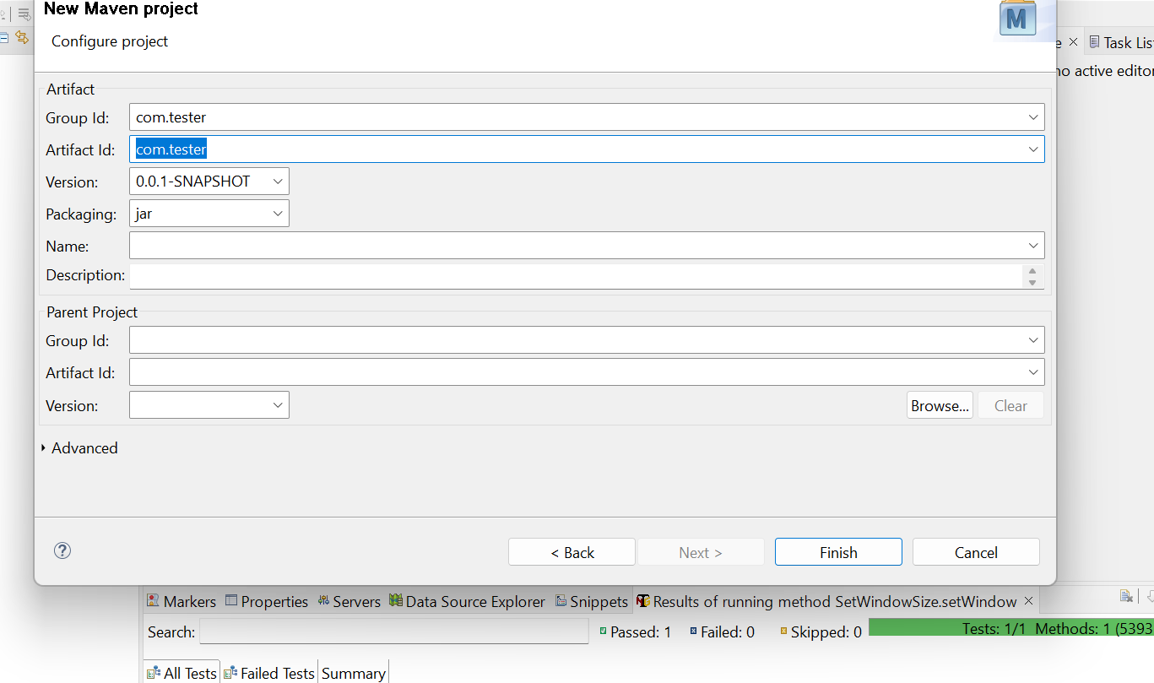

Select the com.tester of main subject java buildpath and add external jars of the library files

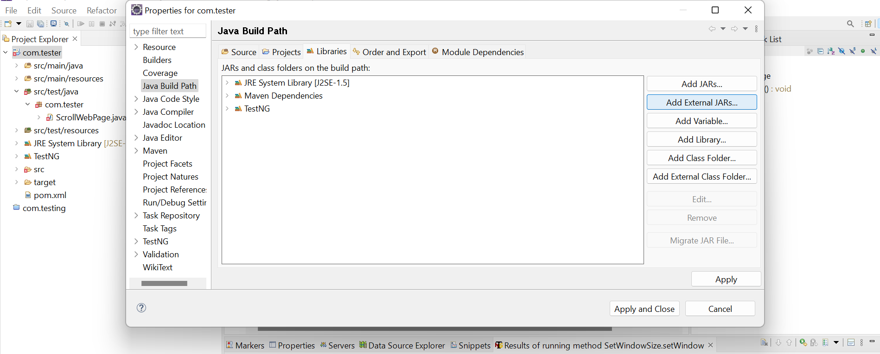

Select the src/test/java>class

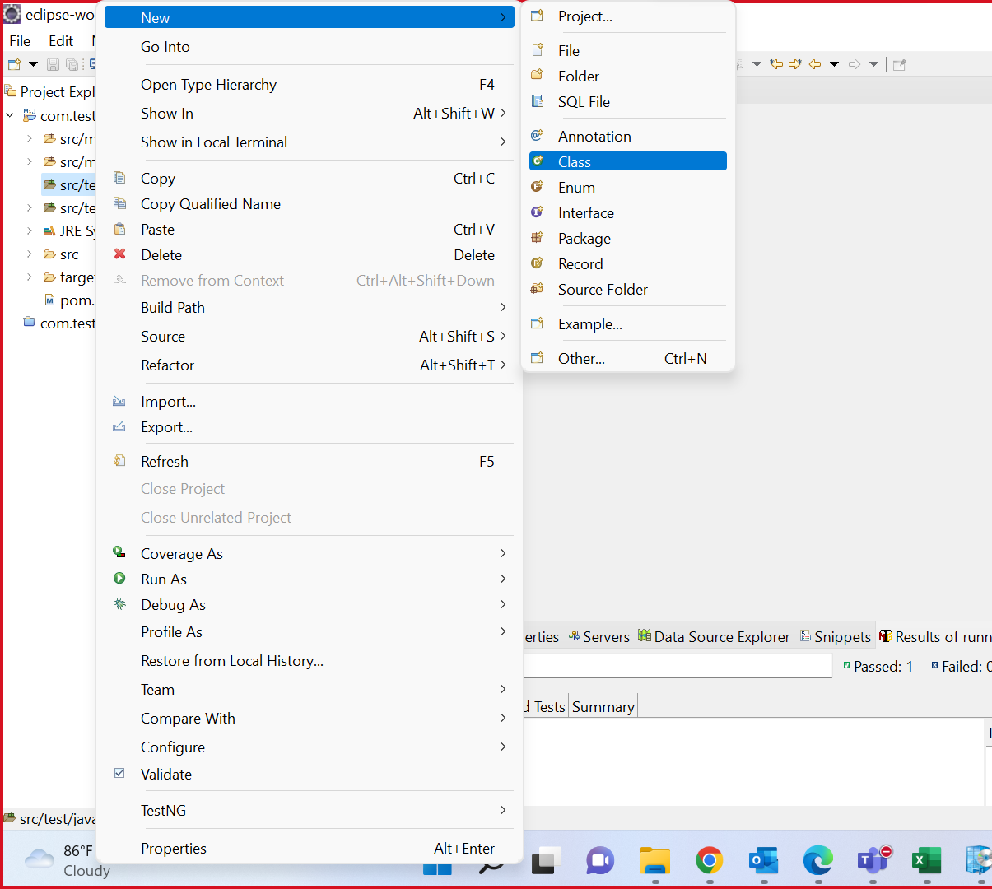

Mention the name u want the name

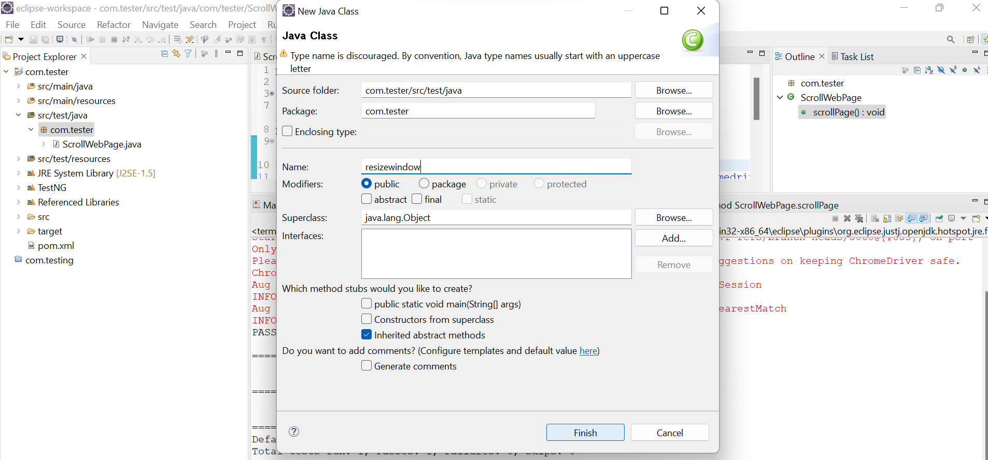

Select and paste the code and save it and run

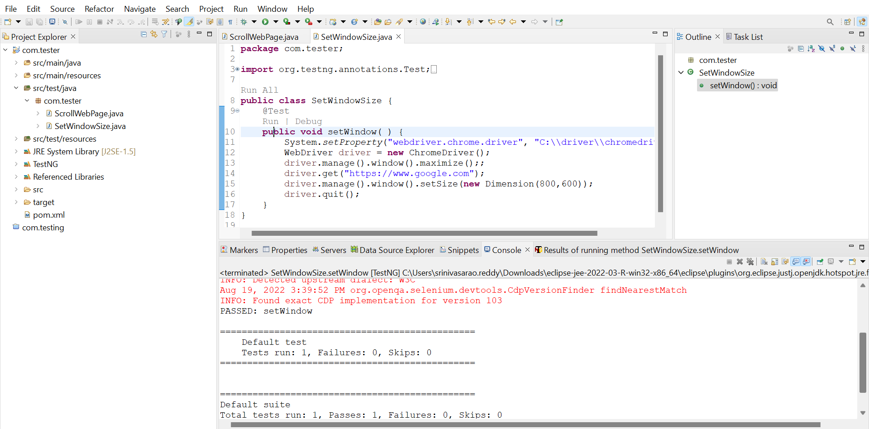

It is the google page of the webpage

